User Guide: Auto-Pod-Deletion

Introduction
This user guide explains how Kubernetes resource cleanup policies work in a Kubernetes cluster. It is intended for users who may not be familiar with the internal automated cleanup mechanisms. The guide provides clear instructions on how to safely manage workloads and avoid accidental deletion of deployments, pods, and services.

Understanding Hard and Soft Limits
The cleanup system defines two key limits that control how long your Kubernetes deployments and pods are allowed to run:
- Soft Limit: When your resource crosses the soft limit duration, it becomes a candidate for cleanup. You can prevent this by adding the required label (see Section 3). If no action is taken, cleanup will occur.
- Hard Limit: This is a strict maximum allowed runtime. Once the hard limit is reached, your deployment, pod, and any linked services will be deleted regardless of labels. There is no way to bypass the hard limit.

Extending Usage Beyond the Soft Limit
If you need your deployment or pod to run beyond the soft limit, you must explicitly add the label below to your YAML specification:
keep-alive: "true"
This label informs the cleanup system that the resource should not be removed when crossing the soft limit.

Example: pod.yaml
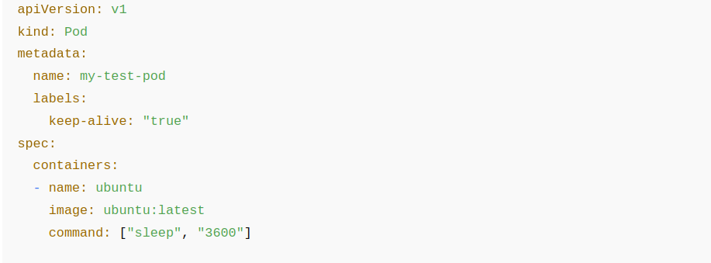
Example: Deployment.yaml
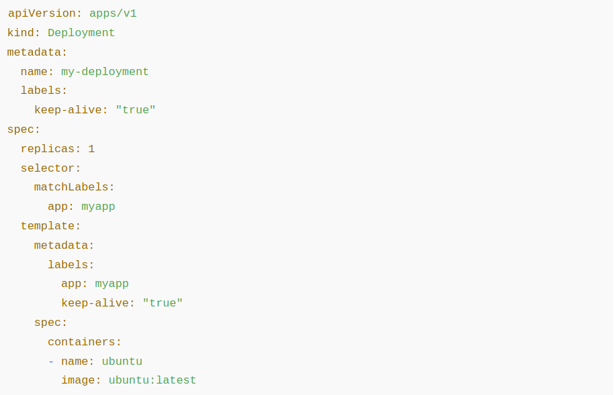

Consequences When Labels Are Missing
If the required label is not present in your deployment or pod specification, the cleanup system will automatically delete your resource—including any associated services—once the soft limit is exceeded.

CPU Utilization Check After Keep‑Alive Label
When the 'keep-alive: true' label is applied, your resource still undergoes an additional safety check: CPU utilization.
If CPU usage falls below the required threshold, this indicates the workload is idle or inactive, and the system may still delete your pod or deployment. This prevents unnecessary resource allocation and ensures fair usage across all users.
Consequences of low CPU activity:
- Your deployment or pod may still be removed.
- Any active but low‑usage workloads may be terminated without further warning.

Responsibility Disclaimer
If your pod or deployment is deleted because it exceeded soft/hard limits, lacked the required keep‑alive label, or failed the CPU utilization threshold, the system will proceed with cleanup automatically. In such cases, the administrator is not responsible for restoring or recovering your deleted resources.

Store Data Locally Before Limit Expiry
It is the user's responsibility to save all important output, logs, or model files to local storage before reaching any runtime limit. Any data stored only inside the pod or container may be permanently lost during automated cleanup.

